**Analyzing the effect of Non-Newtonian behavior of blood in a cavopulmonary connection in context with the Fontan surgical procedure using specific Finite Volume grids**

M Dhoriyaa,d, D Apteb, S Sonic

a, b Department of Mechanical Engineering

G.H Patel College of Engineering & Technology, Gujarat, 388120, India

c Assistant Professor,

Department of Mechanical Engineering,

G.H Patel College of Engineering and Technology, Gujarat, 388120, India

d Corresponding author

**Abstract-** A finite volume method was applied to study the (1) competition of flows in the inferior and superior vena cava in context to the Fontan surgical procedure and its resulting pulmonary connection and (2) hemodynamic shear stress and its role in atherosclerosis. Models corresponding to various degree of offsetting and shape of the inferior vena cava were analyzed to evaluate the flow distribution between two lungs. These models were analyzed using the Carreau model of blood as a non-Newtonian fluid. The optimum flow distribution with minimal energy distribution was obtained, on which the effect of wall shear stress in atherosclerosis was analyzed. The results indicated that by increasing offset, the flow was directed towards right pulmonary artery. To get the desired flow distribution between both arteries a compromise had to be made between flow ratio and energy losses.

Computational analysis concluded that for a certain range of offset between the superior and the inferior vena cava, a negligible region of re-circulation occurred. Also, an abnormality was detected in the ideal flow ratio model corresponding to plaque formation in arteries and its subsequent effects.

**1. INTRODUCTION**

Computational fluid dynamics (CFD) can be defined as the various methods used to analyze complex fluid flow physics around an element with its geometric complexities taken into consideration by numerical techniques that often involve simulations. Not only to solve the problems pertaining to mechanical engineering, CFD can also be used to solve various biomedical dilemmas and optimize surgical techniques.Single ventricle abnormality is a rare form of congenital heart disease which affects the lower chamber of the heart. The chamber might be underdeveloped or missing a ventricle. Despite its relative rarity, patients diagnosed with this disease require considerable amount of time and effort from cardiac surgeons because of the complexity in the patient’s physiology and the resulting complications.

Fontan procedure is a surgical procedure that causes blood to divert its flow from inferior & superior vena cava to left & right pulmonary artery without passing through the right ventricle [5] resulting in a complete bypass of right ventricle. There are two variations of Fontan surgical procedures: (1) Atriopulmonary connection (2) Total cavopulmonary connection; this has further been bifurcated into intracardiac and extracardiac. Studies suggest that the actual design of the procedure affects the flow distribution in anastomotic region [16]. In terms of fluid dynamics, the connection created should be such that the flow distribution should be same as before, loss of head should be low and the wall shear should be optimum.Simulations using finite volume grids and taking the rules of CFD into consideration have been applied to study the above all phenomena. The aim is to select an optimum model in which the loss of head is minimum and the flow distribution is as required.

**2. FONTAN PROCEDURE**

After preliminary research, two patients underwent the Fontan procedure by Fontan and his colleagues. They connected the superior vena cava to the right pulmonary artery and the left pulmonary artery was connected to right atrium. The significance of the hypertrophied right atrium was highlighted by its propelling of the inferior vena caval blood into the pulmonary circulation. The procedure was further extended to the patients with a common atrioventricular orifice or absence of such connection. This led to a conclusion that the atrial component was now a much-reduced lateral wall of right atrium to prevent a pulmonary obstruction of the venous return. Laval (2005) [13] demonstrated experimentally that the most logical form of a right heart bypass was a total cavopulmonary connection.

*2.1 Atriopulmonary connection*

Here, the right atrium is acting like a valve less contractile chamber mediated between the systemic venous and pulmonary artery beds operating at higher pressure than normal. This rise in pressure is the reason for pulsation. The atrium also acts as a reservoir, allowing venous return to proceed continuously. Turbulence is created when the streamlines of the superior and inferior vena caval blood collide in the chamber. This turbulence is a major source of energy dissipation.

*2.2 Total Cavopulmonary connection*

In this procedure, blood returning from the superior vena caval blood is diverted to pulmonary arteries and the inferior vena cava is connected to the arteries. This is achieved by constructing either a simple conduit or a prosthetic patch. Previous studies [5][16] have applied computational fluid dynamics (CFD) models to this connection proving that the connection is beneficial by reducing the risk of atrial thrombosis (blood clot in artery).

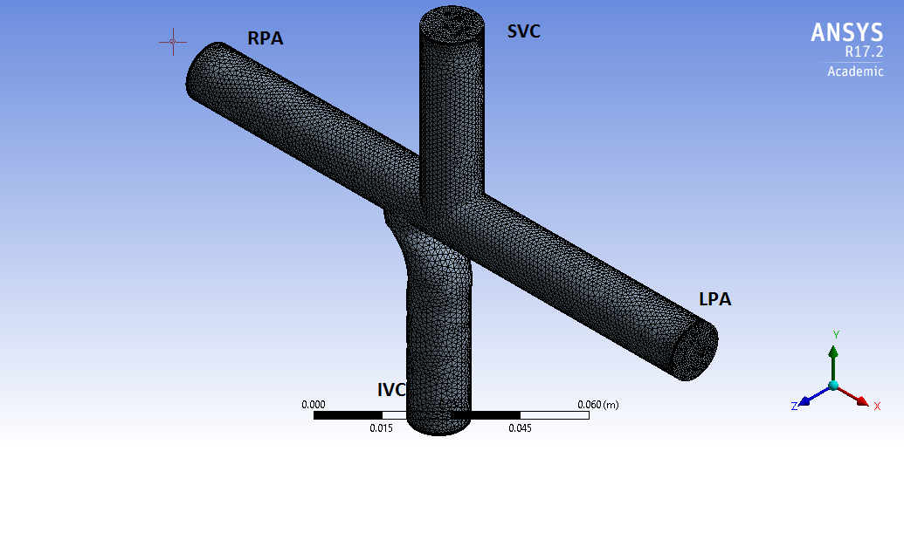

*Figure 1. Diagram of mesh in TCPC model. LPA, Left pulmonary artery; RPA, Right pulmonary artery; IVC, Inferior vena cava; SVC, Superior vena cava.*

**3. METHODOLOGY**

The equations that were solved by ANSYS Fluent [17] to get the solution were the mass conservation equation and the momentum conservation equation.

Continuity equation:

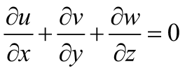

Where, *u* = velocity of flow in x direction

*v* = velocity of flow in y direction

*w* = velocity of flow in z direction

The 14.0-mm inner diameter dimension of the models was based on magnetic resonance imaging (MRI) scans performed on an 8-year-old patient [4]*.* 7 models were made by varying offset from -1.9mm to 3.0mm. After a thorough analysis, blood was considered as the Carreau model as the flow of blood was analogous to the model fluid flow [2]. Carreau fluid is a generalized Newtonian fluid where the effective viscosity depends upon the shear rate. The rheological model is used is stated below [2].

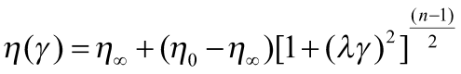

Where,

= viscosity at infinite shear rate

= viscosity at zero shear rate

Relaxation time

*n*= power law index

For blood, =0.0035 Pa s, =.056 Pa, 3.313005s and *n* = 0.3568

The simplest models consider the blood flow as constant. However periodic nature of cardiac system induces a pulsatile, unsteady flow which is considered to have a significant effect on the local velocity and stresses. Matthew SINNOTT et al. [7] suggested that the velocity profile is close to a sinusoidal waveform.

The blood vessels walls are assumed to be rigid. The density of blood is taken as 1060 kg/m3.Therefore, velocity inlet at inferior and superior vena cava was kept pulsatile. The outlet pressure is oscillating due to in pulsatile nature of velocity and it doesn't have a characteristic profile as velocity does. Therefore, the outlet pressure was taken as 904.56 Pa which the average of the fluctuating pressure in vena cava.

**4. RESULTS**

Simulations were carried out on seven geometrical configurations, which correspond to seven different offsets. The details of the mesh of each offset are shown in fig 3.

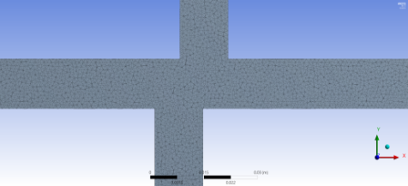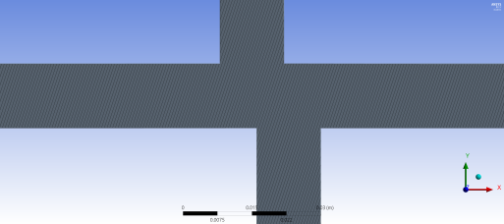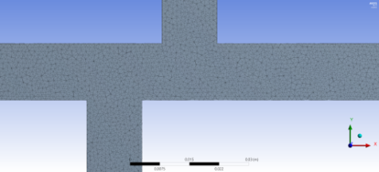

*Figure 3.1 Offset -0.7cm Figure 3.2 Offset 0.8cm* *Figure 3.2 Offset -1.9cm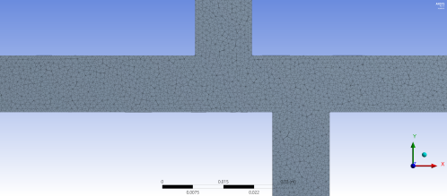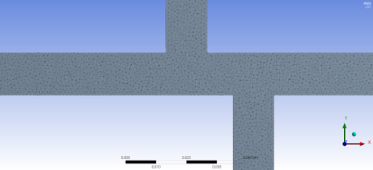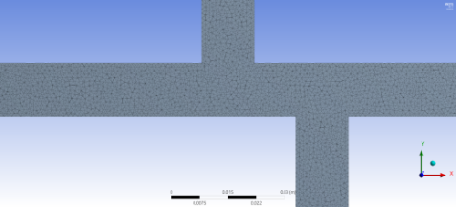*

*Figure 3.4 Offset 1.9cm Figure 3.5 Offset 2.2cm Figure 3.6 Offset 2.5cm*

*Figure 3.0 Cross-section of the geometries of various models in which the offset is varied*

Velocity streamlines were plotted to get a qualitative idea of what happens inside the domain. Each model corresponds to the offset where the stress distribution is analyzed for the diversion of venous blood from the inferior vena cava. For quantitative analysis two energy indices have been adopted. They are total energy loss coefficient Ce and hydraulic dissipated power Wdiss and have the following expression:

Ce=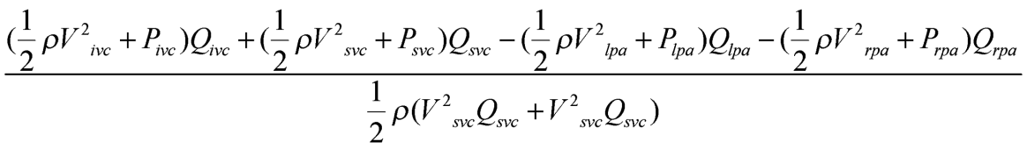

Wdiss=

Where, V, P & Q denote velocity, pressure and flow rate

And the subscript IVC, SVC, LPA, RPA denotes inferior vena cava, superior vena cava, left pulmonary artery and right pulmonary artery respectively.

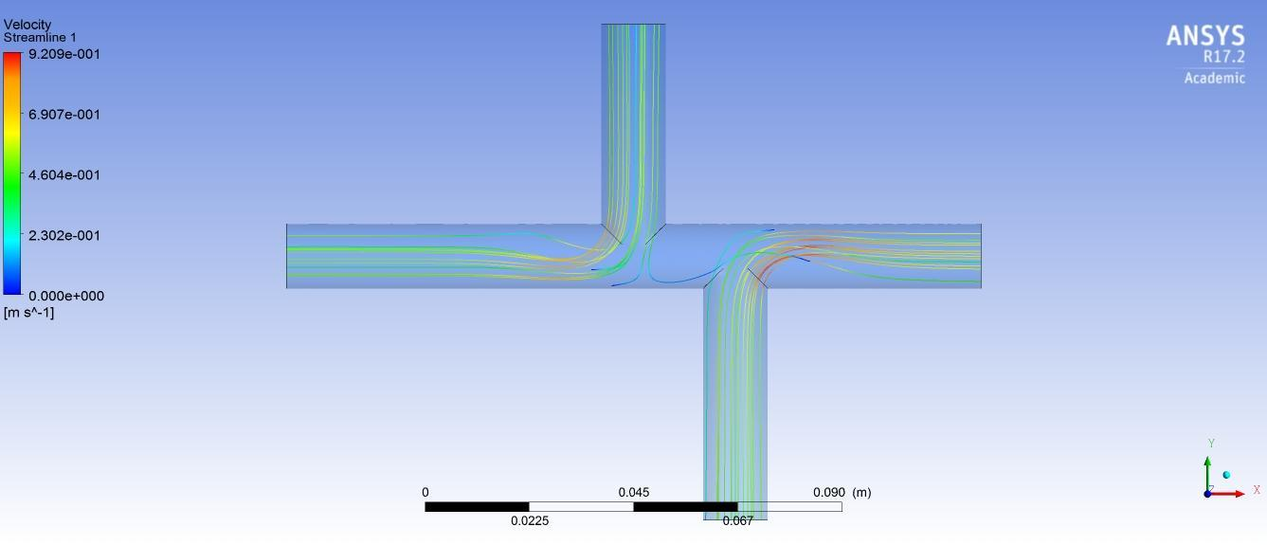

*Figure 4.0 Velocity streamlines of offset 2.2cm*

The ideal flow through the left pulmonary artery should be 45% and in right pulmonary artery should be 55% of total flow. Therefore, the ratio Qlpa/Qrpa should be 0.81. Figure 4 shows the variation of Qlpa/Qrpa the offset. The desired flow distribution is obtained at offset 2. 2cm.The energy loss coefficient at offset 2.2 is 4.327 very close to the average of all energy loss coefficients.

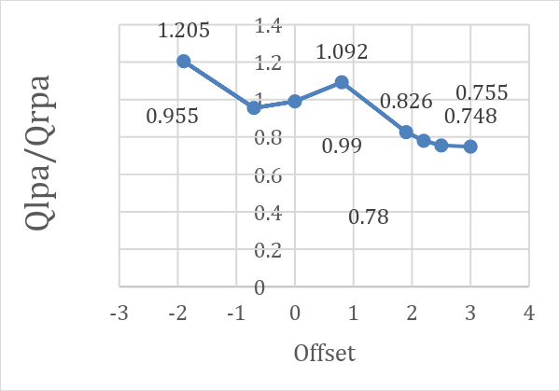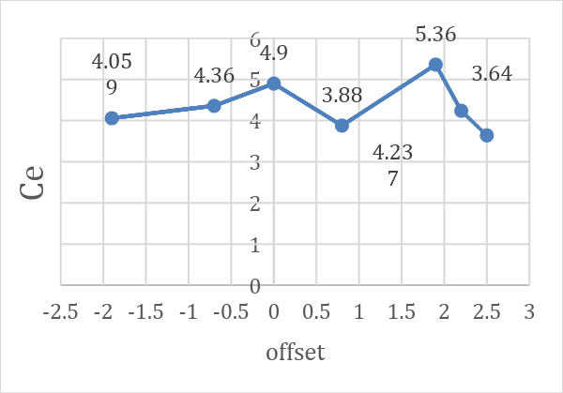

*Figure 5 Graph showing Qlpa/Qrpa vs offset Figure 6 Graph showing Ce vs Offset*

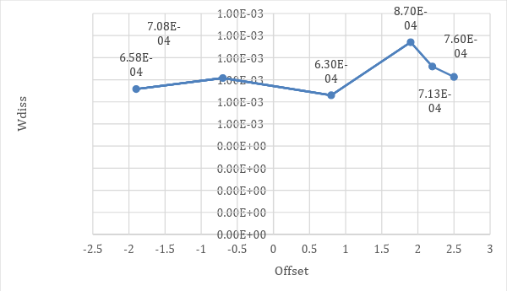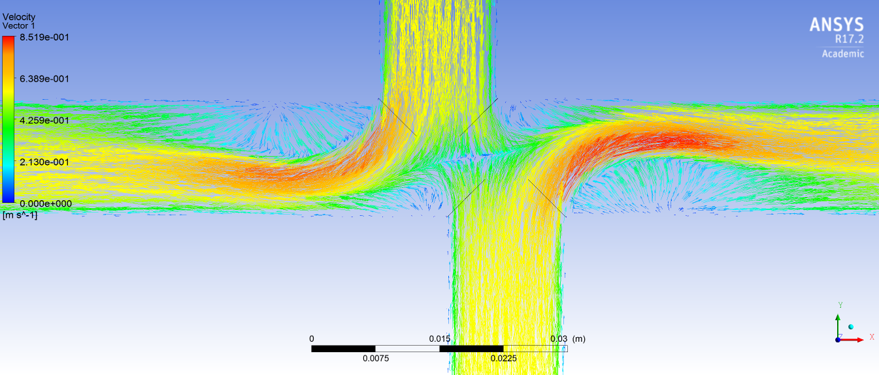

*Figure 7 Graph showing Wdiss vs offset in cm Figure 8.1 Velocity vectors at timestep corresponding to maximum velocity for 0.8 cm offset*

*4.1 Velocity Vectors*

Figure 7 shows the velocity vectors at the midplane of the models. Since the velocity is pulsating therefore the velocity vectors change at every time step. In figure 7, the velocity vectors are corresponding to the time step at which the velocity is maximum. It was observed that there is a region of recirculation between the inferior vena cava and the superior vena cava. As the flow rate is increased to the right pulmonary connection, the size of the region first

increases and then starts decreasing. The size of the zone was minimum for 0.8 cm offset. In the model corresponding to 1.9 cm offset the recirculation region is very close to inferior vena cava. Therefore, this region affects the flow from the inferior vena cava. The particles coming from inferior vena cava go towards this region instead of going towards left pulmonary artery. As the offset was increased from 1.9 cm to 2.2 cm & 2.5 cm, the distance between the region and the flow coming from the inferior vena cava also increased. This also justifies the graph of energy loss coefficient where Ce was maximum for 1.9 cm offset.

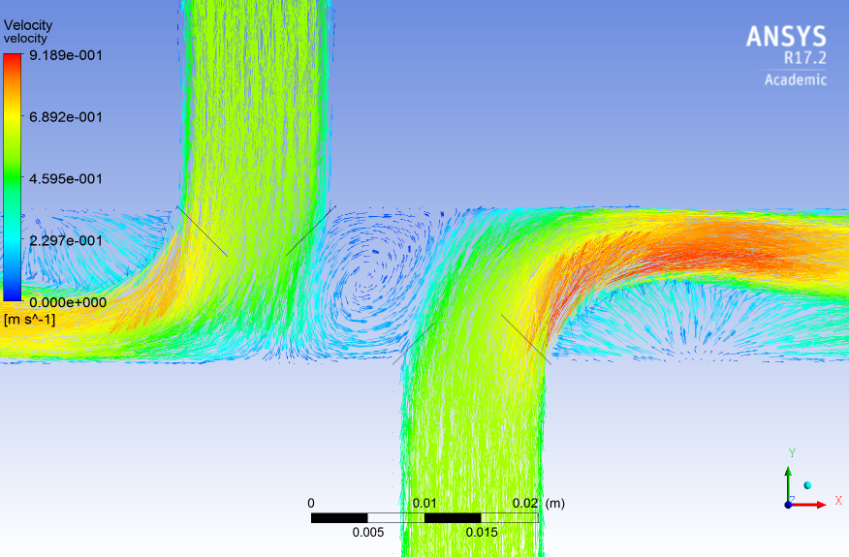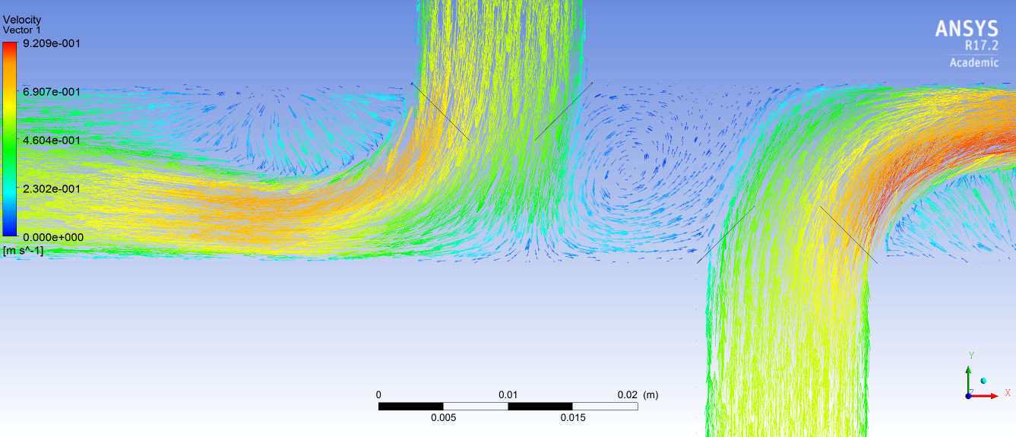

*Figure 8.2 offset 1.9* *Figure 8.3 offset 2.2 cm*

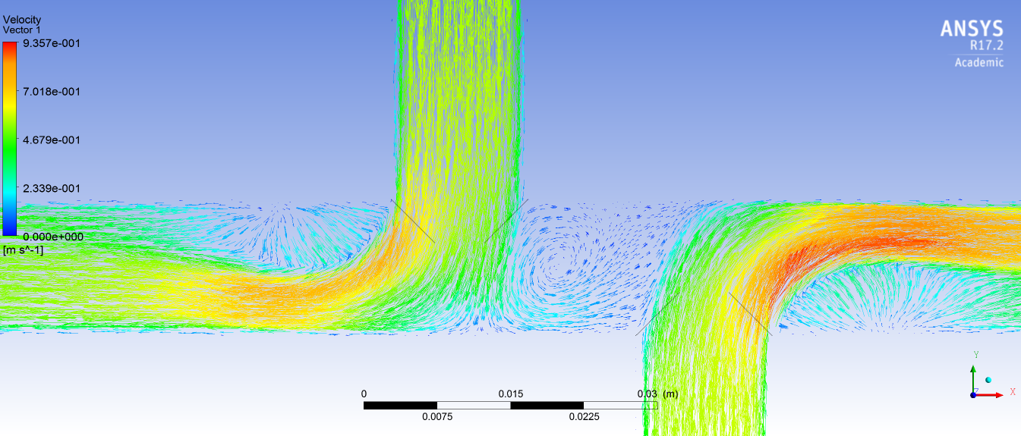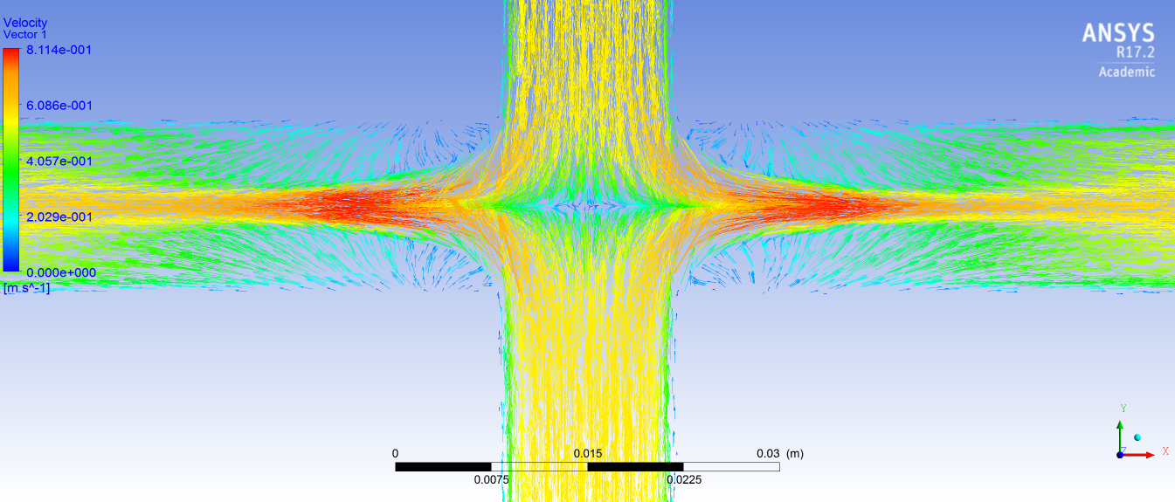

*Figure 8.4 offset 2.5 cm Figure 8.5 offset 0cm*

**5. SHEAR STRESS DISTRIBUTION AND ITS ROLE IN ATHEROSCLEROSIS**

Atherosclerosis is a disease that causes the arteries to be choked up by plaque consisting of fats, cholesterol and some other substances found in blood. As age advances, this plaque hardens affecting blood flow adversely. The reason for atherosclerosis has been debatable, ranging from smoking to high blood pressure to high amount of sugar due to diabetes. Any artery in the body irrespective of the organ it supplies blood to, can be affected by atherosclerosis. The buildup of plaque makes it difficult for blood to flow through arteries and can affect the blood flow adversely causing complications like angina (chest pain), stroke, paralysis or even death. Arterial level shear stress more than 1.5 N/m2 will cause to induce endothelial quiescence and an atheroprotective gene expression profile, while low shear stress (<0.4 N/m2) stimulates an atherogenic phenotype [3]. Since the velocity is pulsatile the wall shear will not be constant. Plaque formation will take place in the region in which the shear i­­­­s low at all the time steps of velocity profile. From the shear stress contours, it was observed that at the region of low shear at time step corresponding to maximum velocity, the shear stress was also low for the rest of the time steps. Also, this region lies between recirculation region and the flow from the inferior vena cava. Since in 0 cm offset there was no recirculation zone therefore there was no low shear zone. This zone was maximum for 2.5 cm. The Shear stress contours for various offsets have been analyzed with range of legend set to 0 and 0.4 Pa in the below figures.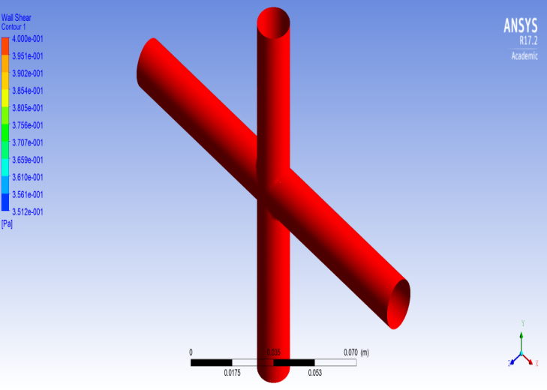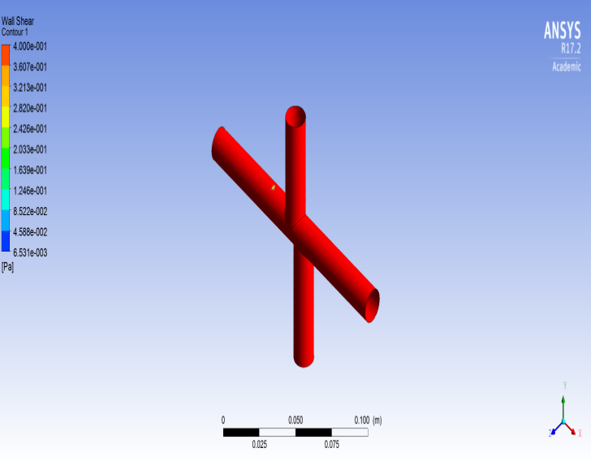

*Figure 9.1 Offset 0 cm Figure 9.2 Offset 0.8cm*

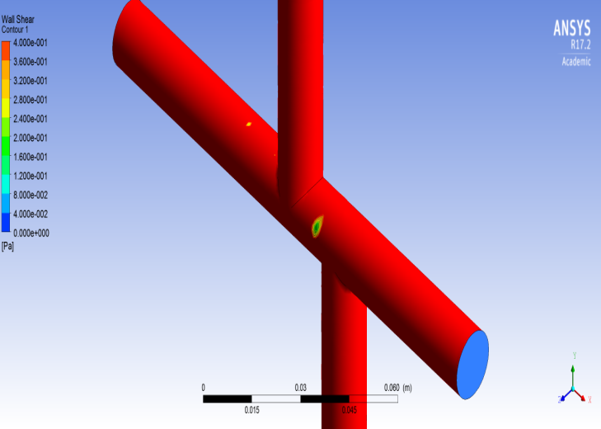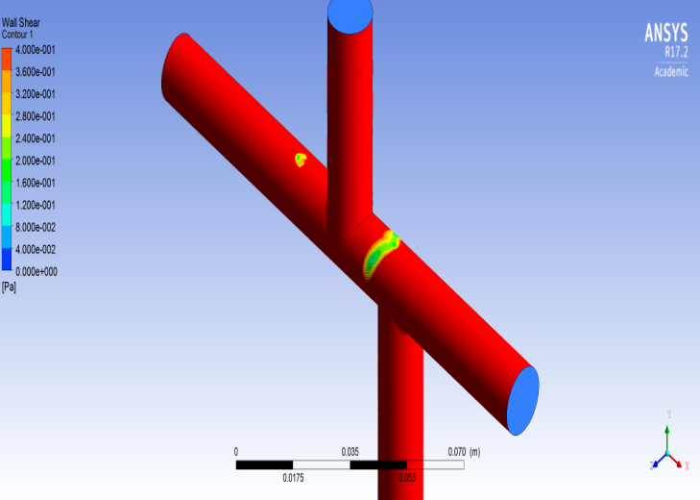

*Figure 9.3 Offset 1.9 cm Figure 9.4 Offset 2.2cm*

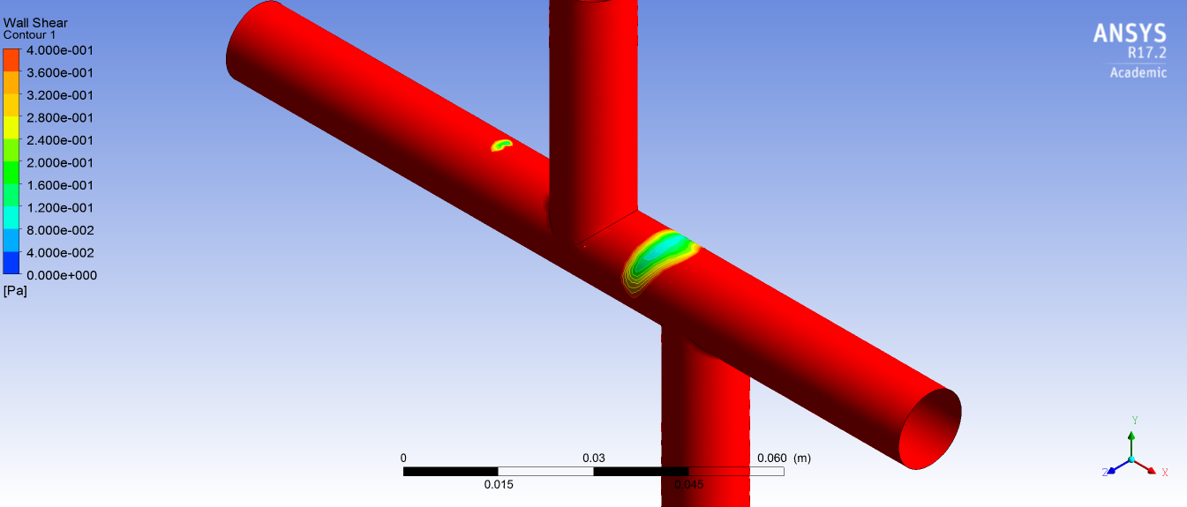 *Figure 9.5 Offset 2.5cm*

**5. CONCLUSION AND FUTURE WORK**

Single ventricle is a congenital heart disease where the lower chamber of the heart might be underdeveloped or missing a ventricle which is cured by the Fontan surgical procedure by diverting vena caval blood to the pulmonary arteries without passing the right ventricle. The surgical procedure affects the flow distribution and the resulting phenomenon was analyzed using computational fluid dynamics and optimized for the required flow distribution with minimum loss of head.

The two types of the Fontan procedure were studied, the atriopulmonary connection and the total cavopulmonary connection before a specific methodology was set and the fluid flow model of blood was taken. CFD analysis was performed on various models of a cavopulmonary connection by varying the distance between inferior and superior vena cava. The ideal flow ratio for left pulmonary artery and right pulmonary artery was 0.81. Out of all the models analyzed, the closest to the ratio was an offset of 2.2 centimeters. The graph visualizing coefficient of energy lost (Ce) vs. offset showed that the maximum energy loss occurred in 1.9 centimeters while for the offset of 2.2 centimeters, the Ce was comparatively low. The Ce was minimum for offset 2.5 centimeters but the flow ratio was distant from ideal flow ratio. The velocity vectors depicted a region of re-circulation between the inferior & superior vena cava which was the reason for varying energy losses for various offset measurements. Models where the region of re-circulation was close to the flow from the inferior vena cava had high energy loss coefficients. For offsets ranging from 0 to 0.8 centimeters, the region of re-circulation was comparatively negligible.

The analysis of formation of shear zone due to plaque build-up in the arteries was further carried out; clinically known as atherosclerosis. After thorough analysis, it was found out that the region of low shear stress occurred near the maximum velocity region: the region between recirculation and inferior vena cava. A zero-offset resulted in a zero-recirculation zone and therefore a high shear zone. Computational analysis found out that the zone was maximum for an offset of 2.5 cm. There seems to be an abnormality in the model corresponding to the ideal flow ratio (2.2 cm offset).

Future work on this research could be conducted as:

* Before the aforementioned research, the Fontan surgical procedure was performed without any computational analysis. However, this paper now paves the way for the study of the cavopulmonary system before the conduction of the surgical procedure. Therefore, the surgeons will be acquainted with the flow distribution before the operation.
* In the model discussed, the wall is assumed to be stationary. Further research can be conducted by considering the expansion and contraction of the arterial walls. The number of factors affecting shear stress zones might differ in this case and might be slightly more accurate.
* Similar analysis can be conducted for other surgical procedures affecting the circulatory system

**6. REFERENCES**

[1] Gijsen F, Van De Vosse F and Janssen J, 1999 The influence of the non-Newtonian properties of blood on the flow in large arteries: steady flow in a carotid bifurcation model *Journal of Biomechanics* **32** 601-608.

[2] Karimi S, Dabagh M, Vasava P, Dadvar M, Dabir B and Jalali, P 2014 Effect of Rheological Models on the Hemodynamics within Human Aorta: CFD Study on CT Image-based Geometry *Journal of non-Newtonian fluid mechanics*

[3] Malek A, Alper S and Izumo S 1999 Hemodynamic shear stress and its role in atherosclerosis *Journal of the American Medical Association.*

[4] Ensley A, Lynch P, Chatzimavroudis G, Lucas C, Sharma S and Yoganathan A 1999 Toward Designing the Optimal Total Cavopulmonary Connection: An In Vitro Study *The Society of Thoracic Surgeons*

[5] De Leval M, Dubini G, Migliavacca F, Jalali H, Camporini G, Redington A and Pietrabissa R 1996 Use of computational fluid dynamics in the design of surgical procedures: application to the study of competitive flows in cavopulmonary connections *The Journal of Thoracic and Cardiovascular Surgery* **111** no.3 502-513

[6] Chan K, Currie P, Seward, J, Hagler D, Mair D and Jamil T 1987 Comparison of Three Doppler Ultrasound Methods in the Prediction of Pulmonary Artery Pressure *Journal of the American College of Cardiology* **9** No.3 549-554

[7] Sinnott M, Cleary P and Prakash M 2006 An investigation of pulsatile blood flow in a bifurcation artery using a grid-free method Fifth International Conference on CFD in the Process Industries CSIRO, Melbourne, Australia.

[8] Dubini G, De Leval M, Pietrabissa R, Montevecchi F and Fumero R 1995 A numerical fluid mechanics study of repaired congenital heart defects. Application to cavopulmonary connection *Journal of Biomechanics*

[9] Morris P, Narracott A, Von Tengg-Kobligk H, Soto D, Hsiao S, Lungu A, Evans P, Bressloff N, Lawford P, Rodney Hose D and Gunn J 2016 Computational fluid dynamics modelling in cardiovascular medicine *Heart* **102** 18-28

[10] Fontan F and Baudet E 1971 “Correction” of tricuspid atresia: 2 cases “corrected” using a new surgical technique *Ann Chir Thorac Cardiovasc* **10** 39–47

[11] Rodbard S and Wagner D (1949) Bypassing the right ventricle *Proc Soc Exp Biol Med* **71** 69–70

[12] Robicsek F (1982) An epitaph for cavopulmonary anastomosis Ann Thorac Surg **34** 208–220

[13] Marc R De Leval 2005 The Fontan Circulation: a challenge to William Harvey *Nature Clinical Practice Cardiovascular Medicine* **2** 202–208

[14] Marcelletti C, Corno A, Giannico S, Marino B 1990 Inferior vena cava– pulmonary artery extracardiac conduit. A new form of right heart bypass *J Thorac Cardiovasc* *Surgery* **100** 228–232

[15] Bove E, De Leval M, Migliavacca F, Guadagni G and Dubini G 2003 Computational fluid dynamics in the evaluation of hemodynamic performance of cavopulmonary connections after the Norwood procedure for hypoplastic left heart syndrome *J Thorac Cardiovasc Surgery* **126** 1040–1047

[16] De Leval, M, Kilner P, Gewillig M and Bull C 1988 Total cavopulmonary connection: a logical alternative to atriopulmonary connection for complex Fontan operations. Experimental studies and early clinical experience *J Thorac Cardiovasc Surgery*.

[17] ANSYS® Academic Research Mechanical, Release 17.1